Magnetic field lines

A magnetic field pattern shows the magnetic field around a magnet.
The pattern is drawn with lines and arrows.
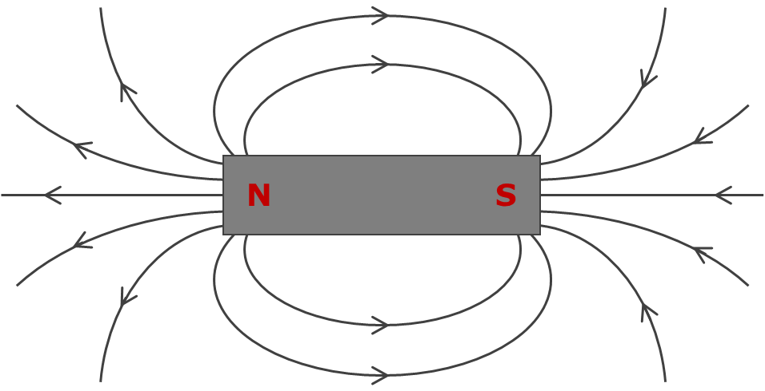
1. What do the lines and arrows show about the direction of the force of the magnet on magnetic objects or on other magnets?
Put a tick (✓) in the box next to the best answer.
A | The direction a magnetic object is pushed or pulled.
B | The direction the north-seeking-pole of another magnet is pushed or pulled.
C | The direction both poles of a magnet are pushed of pulled.

2. What do the lines and arrows show about the size of the force of the magnet on magnetic objects or on other magnets?
Put a tick (✓) in the box next to the best answer.
A | It is bigger where the lines have a free end.
B | It is bigger where the lines are closer to the magnet.
C | It is bigger where the lines are closer together.
D | It is big where there are lines (no lines mean there is no force).

Physics > Big idea PEM: Electricity and magnetism > Topic PEM3: Magnets and electromagnets > Key concept PEM3.1: Magnetic fields
Diagnostic question
Magnetic field lines

Overview
Learning focus: | The magnetic field around a magnet can be represented by field lines, which indicate the size and direction of the force of the magnet on the north-seeking-pole of another magnet.
Observable learning outcome: | Explain what magnetic field lines represent.
Question type: | Simple multiple choice
Key words: | Magnetic field, magnetic field lines, attract, repel

What does the research say?
There has been little research on students’ abilities to plot or interpret patterns of magnetic field lines around bar magnets. Often magnetic field patterns are presented as lines of force and shown as arrows pointing away from the north-seeking-pole and towards the south-seeking-pole. The force of the magnet on a magnetic object is described as bigger where the lines are closer together. This description is confusing in several ways and needs unpicking carefully with students. More accurately, magnetic field lines show the direction in which the north-seeking-pole of a magnet would be pushed or pulled.
When interpreting magnetic fields, the idea that the field is stronger where the field lines are closer together makes no sense to many students. The way students typically plot magnetic fields, with small ‘plotting’ compasses, allows them to add extra field lines at any point in a magnetic field pattern to make the field lines closer together at this point. This suggests that adding field lines makes the magnet stronger! The new field line however, will be closer to adjacent field lines as some points and further away from them at other points. Without accurate measurement of magnetic field strengths, magnetic field patterns can only give an indication of the relative strengths of different points in a magnetic field.
Ways to use this question
Students should complete the question individually. This could be a pencil and paper exercise, or you could use an electronic ‘voting system’ or mini white boards and the PowerPoint presentation.
The answers to the question will show you whether students understood the concept sufficiently well to apply it correctly.
If there is a range of answers, you may choose to respond through structured class discussion. Ask one student to explain why they gave the answer they did; ask another student to explain why they agree with them; ask another to explain why they disagree, and so on. This sort of discussion gives students the opportunity to explore their thinking and for you to really understand their learning needs.

Differentiation
You may choose to read the questions to the class, so that everyone can focus on the science. In some situations it may be more appropriate for a teaching assistant to read for one or two students.
Expected answers
1. B: Field lines show the direction the north-seeking-pole of another magnet is pushed or pulled.
2. C: The force of the magnet on a magnetic object is bigger where the lines are closer together.
How to respond - what next?
1. Showing students a magnetic field pattern of iron filings, or one plotted using a plotting compass, does not demonstrate that magnetic field lines show the direction of a force. Instead, these field patterns show a pattern into which iron filings or compass needles appear to have been pushed.
Answers A and C indicate students who have not applied the understanding that like magnetic poles repel and unlike magnetic poles attract.
2. Students often recognise that the ends of a bar magnet have a stronger pull or push than the middle of the magnet, which may lead them to select answer A. If they understand the force of a magnets on a magnetic object increases closer to the magnet they may choose answer B, which is true near the poles, but not true near to the magnet mid-way between the poles. Answer C is the only answer that shows how both of these observations fit the pattern of the field lines.
A few students may choose answer D because they understand that the magnetic field acts on objects that are closer than a certain distance and not at all on ones further away. This can seem to be the case when a magnet is used to pick up a magnetic object.
If students have misunderstandings about what magnetic field lines represent, it can help for students to experience what happens to the north-seeking-pole of a second magnet when it is moved into the magnetic field of the magnet under investigation. This is easily shown to the whole class using a visualiser or an overhead projector. How to do so is explained in the following BEST ‘response activity’:
- Response activity: Turning magnets
The following BEST ‘response activity’ could also be used in follow-up to this diagnostic question:
- Response activity: Plotting magnetic fields
Acknowledgments
Developed by Peter Fairhurst (UYSEG).
Images: Peter Fairhurst (UYSEG).

